From Traditional Librarian to Specialist in Information and Documentation Sciences:
On the Necessity for Training in an Ever-Changing Profession

Ivona Olariu,
PhD
“Mihai Eminescu” Central University Library, Iasi
Adriana Szekely,
PhD
“Lucian Blaga” Central University Library, Cluj-Napoca

Abstract
The paper presents the synthesis of the updated preferences for professional training of the members of the Association of Librarians in Romania (ALR). The professional development avenues have been emphasized following a study performed during September-November 2022, on a national, representative sample.
The professionals in the field have been consulted regarding the motivation to participate in training programs, and the importance given to professional training, their expectations upon completing them, their involvement in such programs in the last 3 years (financial resources, alloted time). The training topics chosen by respondents were analyzed, together with the criteria on which choosing the programs is based, difficulties encountered etc.
In order to have a complete image of the evolution of ALR members’ preferences, the paper compares the current results with those from 2016, obtained from a similar study. The differences introduced by the pandemic are analyzed, difference which brought the necessity for new approaches in how the profession is conducted and, thus, the gaining of new competences and abilities.
Conclusions help guide the association in its role as the primary provider of training programmes for the community, in selecting the topics to be covered in the future. In addition to the choices expressed by the respondents, the paper also presents the studies conducted by the association regarding the new development directions for this profession which is continuously redefined in relation to the new informational environment.

Keywords: professional training, Association of Librarians in Romania, library science, survey, questionnaire, informational environment.

1. Introduction

The aim of the study was to identify the training needs of librarians, starting from the problems faced by these professionals and continuing with the design of specific objectives and actions taken to solve them.
The results of this survey highlighted the directions of professional training of infodocumentary specialists needed to be developed in the next period, being a benchmark for the organization of programs and study plans in the organization of specialization courses.
The study initiated in 2016 was repeated in 2022. The answers from 2022 were analyzed compared to those obtained by processing the questionnaire from 2016, underlined the changes in professional training preferences in the context of the pandemic period (2020-2021).

2. Methodology

2.1. Participants
Data was collected from a nationally distributed sample, anonymously and voluntarily, in two waves, six years apart (Annex 1 - 2016, 2022). The survey was distributed through a secured link via Google Forms. The total sample consisted of 1018 respondents; there were 447 responses in 2016 and 571 responses in 2022. Data about respondents from each wave are presented in Table 1.
2.2. Target population: 1200 ALR members, in 2016, respectively 760, in 2022. In both cases it was a representative sample.
2.3. Survey structure:
The first survey included 24 questions (Q₁) and 2022 version includes 25 questions (Q₂), about:
1. Motivation to complete programs of professional training, importance given to them and expected results (Q₁1, Q₁2, Q₁5, Q₁6, Q₁7), (Q₂1, Q₂2, Q₂5, Q₂6, Q₂7)
2.Involvement in previous programs (Q₁3), (Q₂3)
3. Time and financial resources invested in professional training (Q₁4), (Q₂4)
4.Preferred method of training (Q₁8), (Q₂8)
5.Details regarding the organization, theme and criteria for choosing such a program; difficulties which could limit participation (Q₁9, Q₁10, Q₁11, Q₁12, Q₁13), (Q₂9, Q₂10, Q₂11, Q₂12, Q₂13)
6.A perspective on the necessity for professional training of colleagues (Q₁14), (Q₂14)
7.Demographics and socio-professional environment of origin (Q₁15, Q₁16, Q₁17, Q₁18, Q₁21, Q₁22), (Q₂17, Q₂18, Q₂19, Q₂20, Q₂23, Q₂24)
8.Data regarding professional experience and highest level of studies (Q₁19, Q₁20, Q₁23, Q₁24), (Q₂21, Q₂22, Q₂25).
In 2022, Q₁23 was removed. The question regarded the initial training (higher education in information and documentation science or another field, secondary education in information and documentation science or secondary education in another field).
Two other questions (Q₂15, Q₂16) have been added, about how the pandemic affected professional training, as well as the main provider of professional training during 2020-2022.
Number of options offered in Q10 increased from 13 (Q₁10) to 18 (Q₂10). In addition, the number of choices for Q12, regarding the difficulties encountered in attending the courses, increased from 5 (Q₁12) to 6 (Q₂12).
Data pre-processing and analysis
The dataset was constructed by merging the data from the 2016 and the 2022 surveys (waves), for questions that matched. All reported statistics were extracted separately for each wave.
For the multiple-choice items (i.e. questions Q1, 5, 7, 8, 9, 11, 12), response categories were coded with 1 each time they were mentioned, missing otherwise and absolute frequencies for each category were extracted.
For the forced-choice items (i.e., questions Q2, 3, 4, 6, Q₁15, Q₁16, Q₂17, Q₂18), we reported relative frequencies for each response category. Ordinal (i.e., questions 13 and 14) and Likert-type (i.e., question Q10) items were reverse coded so that the higher/lower categorical value corresponded to the higher/lower number (e.g., 1 recoded as 5/6 and vice versa).
For such items, we reported relative frequencies for each response category. For the ordinal items, we also reported central tendency and dispersion indicators (median, values of the 25th and 75th quartiles and inter-quartile range).
We also performed cross-tabulations between certain demographic variables (age, education, type of library) and extracted relative frequencies for each item and response category.
Data cleaning was done in Microsoft Excel, with the Power Query module. Data transformation, analysis and visualization were done in R Studio, R version 4.2.1, using packages dplyr and ggplot2 from the tidyverse collection (Wickham et al., 2019) and packages summarytools (Comtois, 2022) and likert (Bryer&Speerschneider, 2016).

3. Results

Table 1: Demographic information, socio-professional environment, data related to professional experiences and level of completed studies

 |  | Wave
 |  | 2016 |  |  | 2022
Variable | Values | Frequency (%) | Distribution |  | Frequency (%) | Distribution
Gender  Q₁16,Q₂18 | Masculine  Feminine | 27 (6.1%)  417 (93.9%) |  |  | 39 (6.9%)  529 (93.1%)
Age  Q₁15,Q₂17 | <25  26-35  36-45  46-57  58-65 | 0 (0.0%)  44 (9.9%)  145 (32.6%)  223 (50.1%)  33 (7.4%) |  |  | 0 (0.0%)  37 (6.5%)  151 (26.5%)  328 (57.6%)  53 (9.3%) | 
Residency  Q₁17,Q₂19 | Rural  Urban | 85 (19.0%)  362 (81.0%) |  |  | 147(25.7%)  424 (74.3%) | 
Place of work  Q₁18,Q₂20 | Rural  Urban | 83 (18.6%)  364 (81.4%) |  |  | 133(23.3%)  438 (76.7%) | 
Length of employment  Q₁19,Q₂21 | 5 years or less  6 to 10 years  11 to 15 years  16 to 20 years  21 to 25 years  26 years or more | 7 (1.6%)  31 (6.9%)  66 (14.8%)  71 (15.9%)  92 (20.6%)  180 (40.3%) |  |  | 17 (3.0%)  36 (6.3%)  52 (9.1%)  96 (16.8%)  113 (19.8%)  257 (45.0%) | 
Length of employment in the field  Q₁20,Q₂22 | 5 years or less  6 to10 years  11 to 15 years  16 to 20 years  21 to 25 years  26 years or more | 49 (11.0%)  85 (19.0%)  81 (18.1%)  90 (20.1%)  82 (18.3%)  60 (13.4%) |  |  | 77 (13.5%)  79 (13.8%)  64 (11.2%)  119 (20.8%)  107 (18.7%)  125 (21.9%) | 
Type of library  Q₁21,Q₂23 | School/High school  Specialized  Public  National  University | 348 (77.9%)  16 (3.6%)  15 (3.4%)  7 (1.6%)  61 (13.6%) |  |  | 287 (50.3%)  10 (1.8%)  141 (24.7%)  41 (7.2%)  92 (16.1%) | 
Education  Q₁24,Q₂25 | High school graduate  Bachelor’s degree  Postgraduate degree Master’s degree  PhD | 52 (11.6%)  155 (34.7%)  149 (33.3%)  78 (17.4%)  13 (2.9%) |  |  | 59 (10.3%)  174 (30.5%)  183 (32.0%)  127 (22.2%)  28 (4.9%) | 
Position  Q₁22,Q₂24 | Other  Execution  Managerial | 13 (2.9%)  413 (92.4%)  21 (4.7%) |  |  | 13 (2.3%)  507 (88.8%)  51 (8.9%) | 

Q1: The reasons for attending professional training programs (Fig.1):
The most important factors in the involvement in professional training programs are the need to acquire new professional competences and the development of the personal professional training portfolio.
The respondents, employees of university, national, public, specialized and school libraries, consider having new professional competences a necessity, and are therefore attending such programs: more than 86% in 2016 and over 92% in 2022. The most significant increase occurs for the university libraries personnel (from ~87% to ~92%), while the public libraries show a decrease (from 100% to ~94%).
The second factor which influences the completion of specialization courses is the development of the professional training portfolio, with increasing percentage from 2016 to 2022, for all categories of libraries, except the specialized ones.
Results show that the lowest influence in taking such a decision is the recommendation of the colleagues to attend such courses.

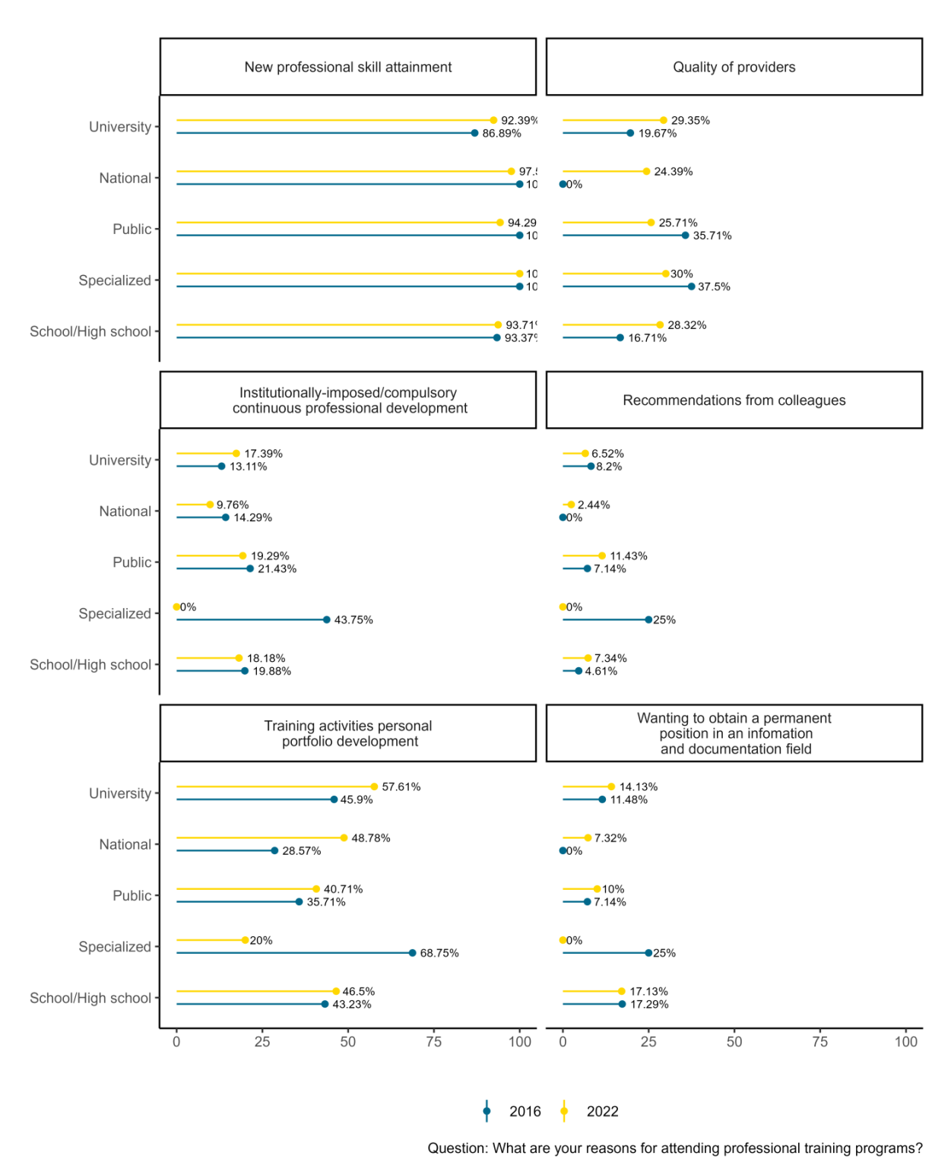
Figure 1

Q2 For you professional training is: a.Very important; b. Of medium importance; c. Important; d. Little important; e. No important; I can not appreciate
In 2016: 73,4% chose option a, 20,8% consider professional training, for 5,1% it is of medium importance, and 0,7% declare they cannot evaluate.
The 2016 results are similar to those in 2022: 74,1%, 5,3%, 20,3% and 0,4%.
Q5: When asked about their biggest expectations from a training program, in a multiple choice question (Figure 2), results indicate a significant increase in all 4 options, with the highest percentage in the case of new ways to exercise the profession (53,9 in 2016, 86,8 in 2022) and exchange of experience and good practices (from 36% to over 70%).
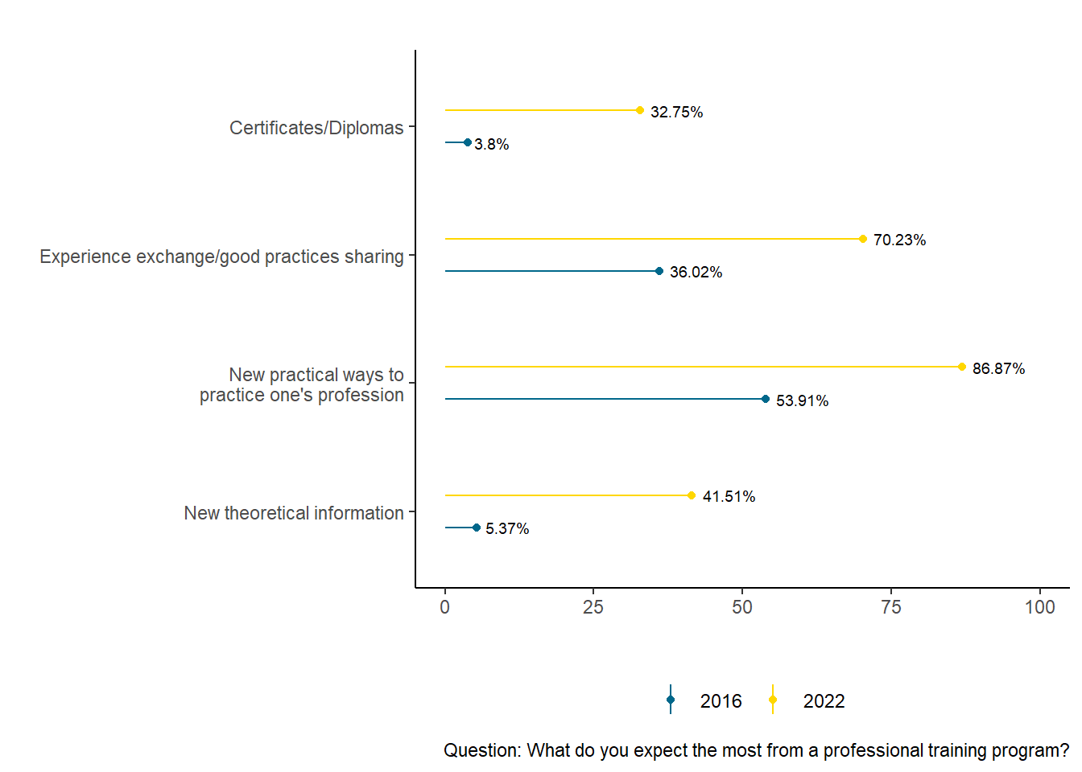
Figure 2

Q6: Regarding the opinion on the personal level of professional training according to the requirements of the current and prospective positions, results show that respondents of both surveys consider to a large or very large extent that they possess professional training corresponding to their job (over 80%) and below 2% declare that their training fulfills to a small or very small extent the requirements:

2016 2022
1. To a very small extent 0.4% 0.5%
2. To a small extent 0.9% 1.4%
3. To some extent 17.9% 18.0%
4. To a large extent 58.4% 56.2%
5. To a very large extent 22.4% 23.8%

Q7 Speaking about attending professional training programs (Figure 3):
The 3 answer options maintain the same order (in 2022, compared to 2016), such that the development of professional competences represents the main motivation for over 89% in the first survey, and more than 91% in the second. The second places is taken by the support in exercising the profession, with increasing percentage in 2022 (over 51%, from 28%). Below 20% say that professional training ensures the possibility to advance in the workplace!

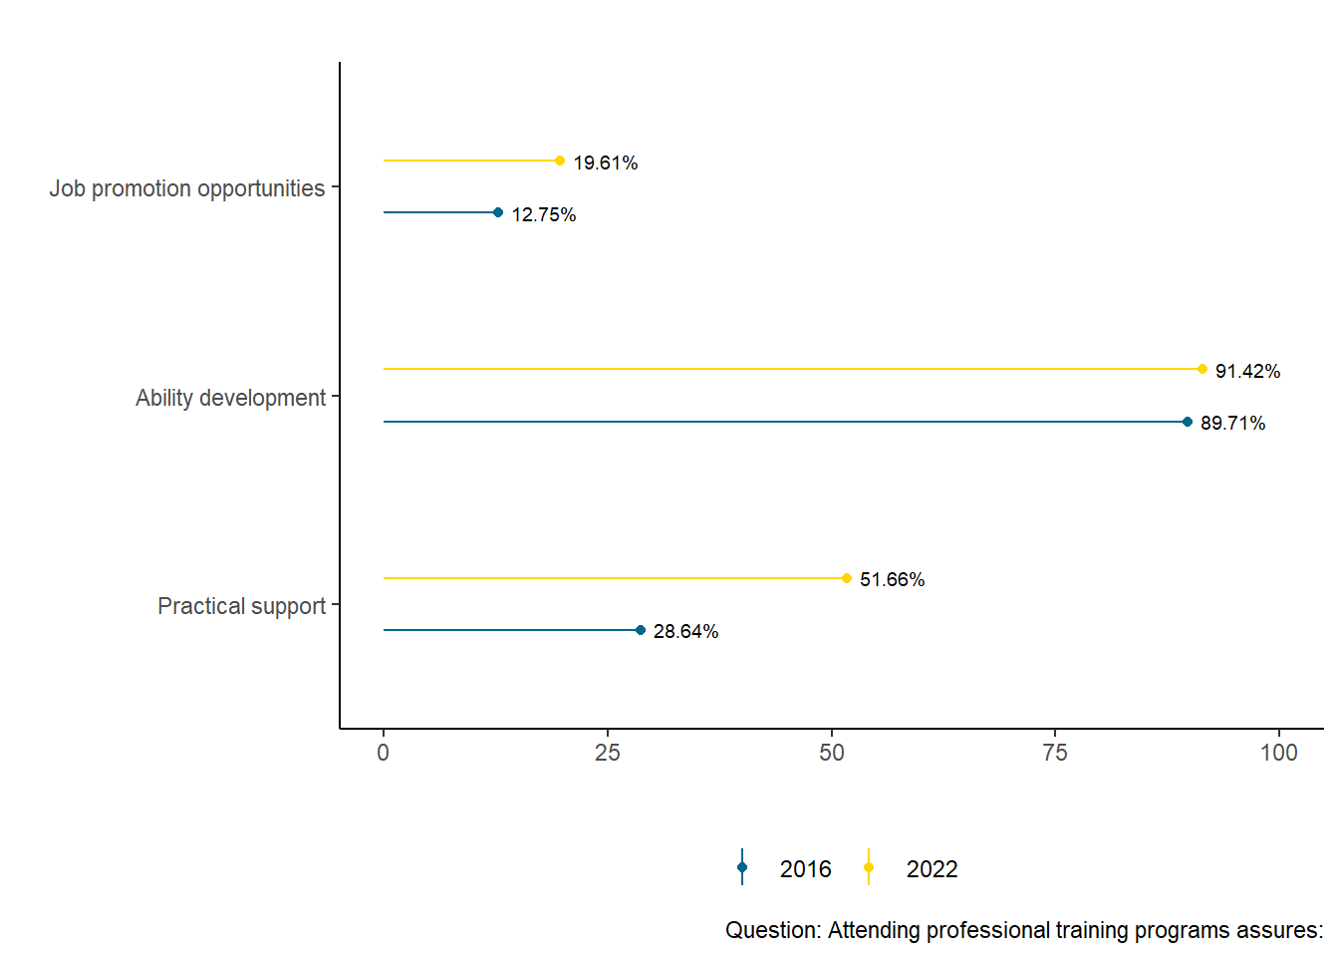
Figure 3

Q3 For the question regarding the number of completed professional training programs, answers are as follows: in 2016, 6,3% were involved in more than 6 programs, 7,8% in 5-6, 25,5% in 3-4 programs, 49,7% in 1-2 and only 10,7% declared they did not get training.
After 6 years, these percentages changed as such: 10,7% – more than 6 programs, 8,1% – joined 5-6 programs, 17,2% – completed 3-4 programs, 35% – only 1-2 programs, while 29,1% have not completed any form of training in the last 5 years!
Q4 Asking about resources investement (time and money) for professional training (different types of courses, LIS field bibliography), the respondents’ opinions are presented in Table 2:
Table 2:
2016 2022
None  Very little  Little  Some  Many  A lot | 3 (0.7%)  18 (4.0%)  33 (7.4%)  193 (43.2%)  172 (38.5%)  28 (6.3%) |  |  | 5 (0.9%)  35 (6.1%)  48 (8.4%)  238 (41.7%)  195 (34.2%)  50 (8.8%) | 

Q8: What types of training do you consider adequate?
Answers to this questions place practical courses realized with teachers from within ALR as the top choice, both in 2016 and 2022, with a percentage of 74.4 and 73.6, respectively; the second place choice is the training with a practical, interactive component – workshops on various specialization topics, with increasing percentages in 2022 (over 69%) compared to 2016 (about 66%) – Figure 4.

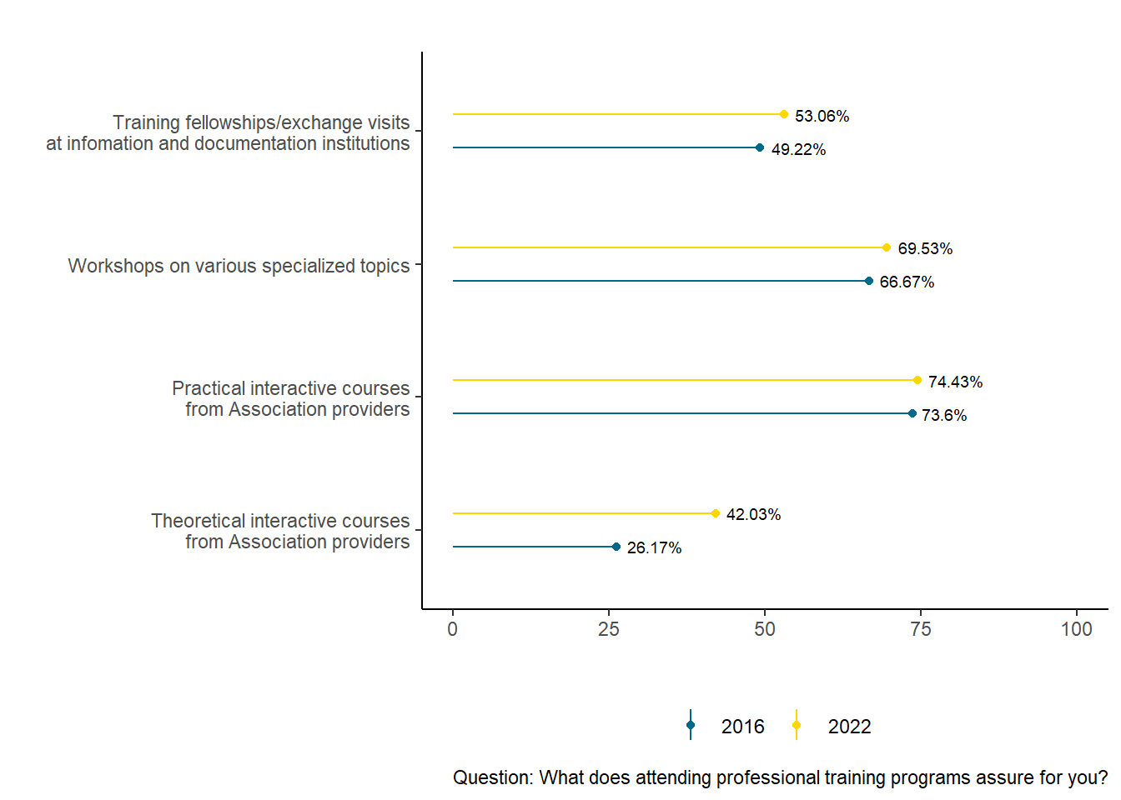
Figure 4

The following questions ask for details about the organization, theme and criteria in choosing such a program, difficulties which might prevent attending: (Q₁9, Q₁10, Q₁11, Q₁12, Q₁13), (Q₂9, Q₂10, Q₂11, Q₂12, Q₂13).
Answers to question Q9: What aspect from your professional training would you like to improve? (Figure 5) place library and information science competences as the top choice , in almost equal percentages between 2016 and 2022, the second choice is ILS competences, showing a significant increase in the requests for ICT competences (from 40% to over 54%) and communication and relational competences (from approximately 42% to about 51%).
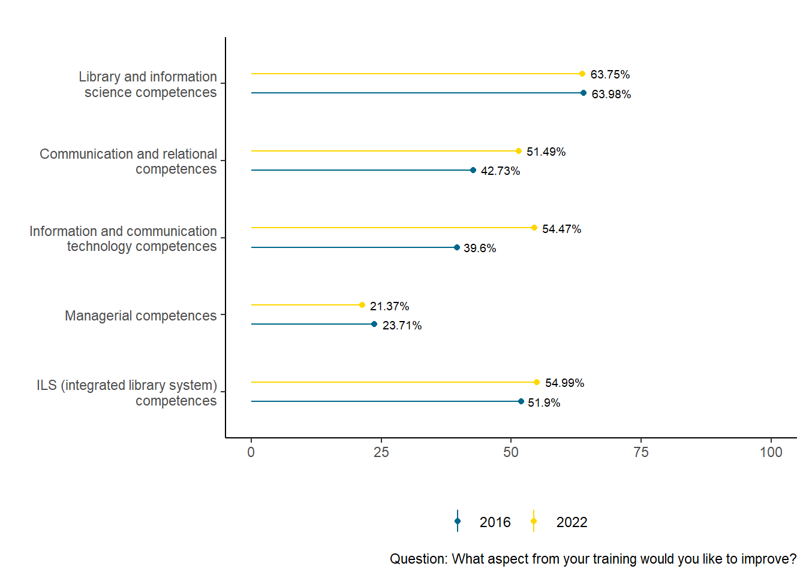
Figure 5

Q10: Course subject preferences:
The respondents were asked to grade on a scale of 1 to 5, to what extent they consider important the participation in courses on topics presented below. The results were interpreted according to the Methodology section described previously (very useful, useful, a little useful, irrelevant, not at all useful).
1. Digital libraries. Institutional repository (licensed resources/archives) vs institutional repository (open access) is a new subject in the 2022 survey and is considered useful and very useful by more than 72% of respondents, while approximately 12% did not choose any option (in 2022).
2. Research and publishing in library and information sciences is also a new topic, the 2022 responses showing that it is useful/very useful for over 60%, while 14.41 consider it not very useful, and over 16% did not choose any option. We will study the options for this topic based on age and the type of library the respondents work at.
3. Items/documents borrowing & ILL is a topic with decreasing popularity in 2022 – 58.17% (compared to 2016, when it was considered useful/very useful by 84.27%). 20.56% of respondents did not pick this option at all in their preferences.
4. The topic regarding Preservation/conservation of the collections is a top choice (useful/very useful) among 72.36% in 2016 and only 56.94% of respondents in 2022. Also, 20.56% of them do not list this answer at any place on the scale.
5. Information literacy is one of the favorite topics among professionals, with useful/very useful percentages varying between 83.59% (in 2016) and 71.18% (in 2022).
6. Preferences for Collections development drop from 79.55% (in 2016) to 65.56% (in 2022), when it was considered useful/very useful, 14.38% and 11.42% respectively see it not very useful. The remaining percentages account for answers of irrelevant, not at all useful or when the topic was not selected at all.
7. The record of library collections is of interest for approximately 68% of the professionals (in 2016), and slightly lower in 2022 (64%). For over 31% and 19%, the topic was a little useful or not at all useful, and not selected at all, respectively (over 16% in 2022).
8. The wish to train in Integrated library systems stays high (>78% in 2016 and almost 76% in 2022).
9. More specialized and current topics were proposed, such as Bibliographic references management tools, and the results prove the necessity to know them by the specialized personnel, as well as the analysis of the origin of the respondents. The topic is useful/very useful for 58.53% of the respondents, and considered a little useful, irrelevant, not at all useful by >22% or not selected by over 18% (în 2022).
10. The necessity to organize courses on Library law is proven by the answers which consider the topic useful/very useful (86.52% in 2016, 70.13% in 2022), considered a little useful, irrelevant, not at all useful by 13.48% and 15.82% of the respondents, respectively. The answers will be detailed based on age, level of studies and type of library of origin for this question as well.
11. Traditional activities like Documents processing (cataloguing, classification, indexing) remain among the librarians’ preferences, because they are useful both for the construction of the library catalogues, as well as, in a simplified form, of digital repositories. Thus, although the percentage decreased, 87% in 2016 and 67% in 2022 of the respondents would take part in cataloguing training. High percentages were calculated for indexing too, although the level of interest is also decreasing in 2022.
12. The possibility of obtaining additional funding, even though libraries are, depending on their type, not very eligible to apply directly, determined the specialized personnel to orient themselves towards courses on library project management (79.11% in 2016 and 76.10% in 2022). Also, the percentage of those who consider the topic a little useful is decreasing in 2022 (5.45%) compared to 2016 (14.38%), and the irrelevant or not at all useful opinions are few, and relatively constant (2016 - 6.52% vs 2022 - 6.15%).
13. Library marketing, a topic which was successful in the past (88.54%) being considered useful/very useful in 2016, is decreasing in 2022 (68.90%). In 2022, 16.52% of the respondents did not pick this option at all.
14. Library statistics and evaluation is a topic perceived as abstract, with data difficult to collect and interpret, and decreased request from ~ 84% to ~ 58%, drop caused by the almost 20% of non-respondents in 2022.
15. Electronic scientific resources in information & documentation change from 82.69% to 71.18% in 2022, when the non-respondents percentage is 16.87%.
16. The topics regarding Research outputs management and Access models to electronic scientific literature are newly introduced in the 2022 version of the survey, and results show the low level of knowledge and/or understanding of new concepts in LIS, and therefore the need for training the specialist who can then teach users how to access the electronic scientific literature, and support the research activities through research output management. The correlation between the reduced level of knowledge of these topics and other factors measured in the survey will be analyzed. 66.66% of respondents say the topic of access models to electronic scientific literature is useful/very useful, 16.70% did not answer, and the rest consider it a little useful, irrelevant, or not at all useful. The level of knowledge and application of the concept is even lower in the case of research outputs management, a new but niche subject, being useful/very useful for 53.60% of the respondents, with a significant number of non-respondents at over 21%. The results are presented below, in Figure 6.
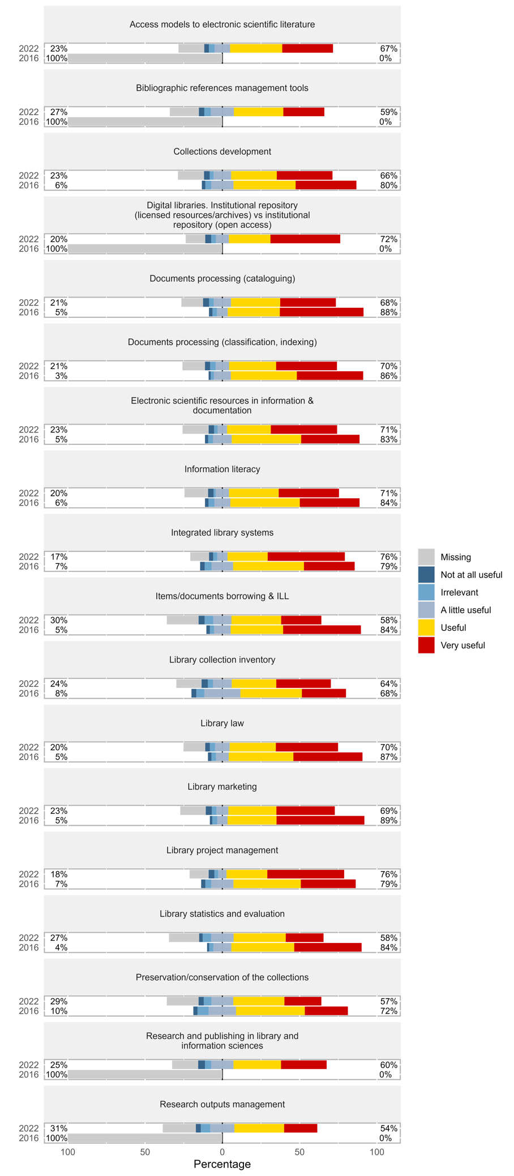
Figure 6
Q11 What are the 3 most important criteria you take into accout when choosing a training course/module? Of the 6 possible options, the top choice is the addressed topic, followed by the training provider/quality of trainers, and methodologies of training in almost equal percentages. Factors which influence the decision less are costs and program duration (Figure 7).
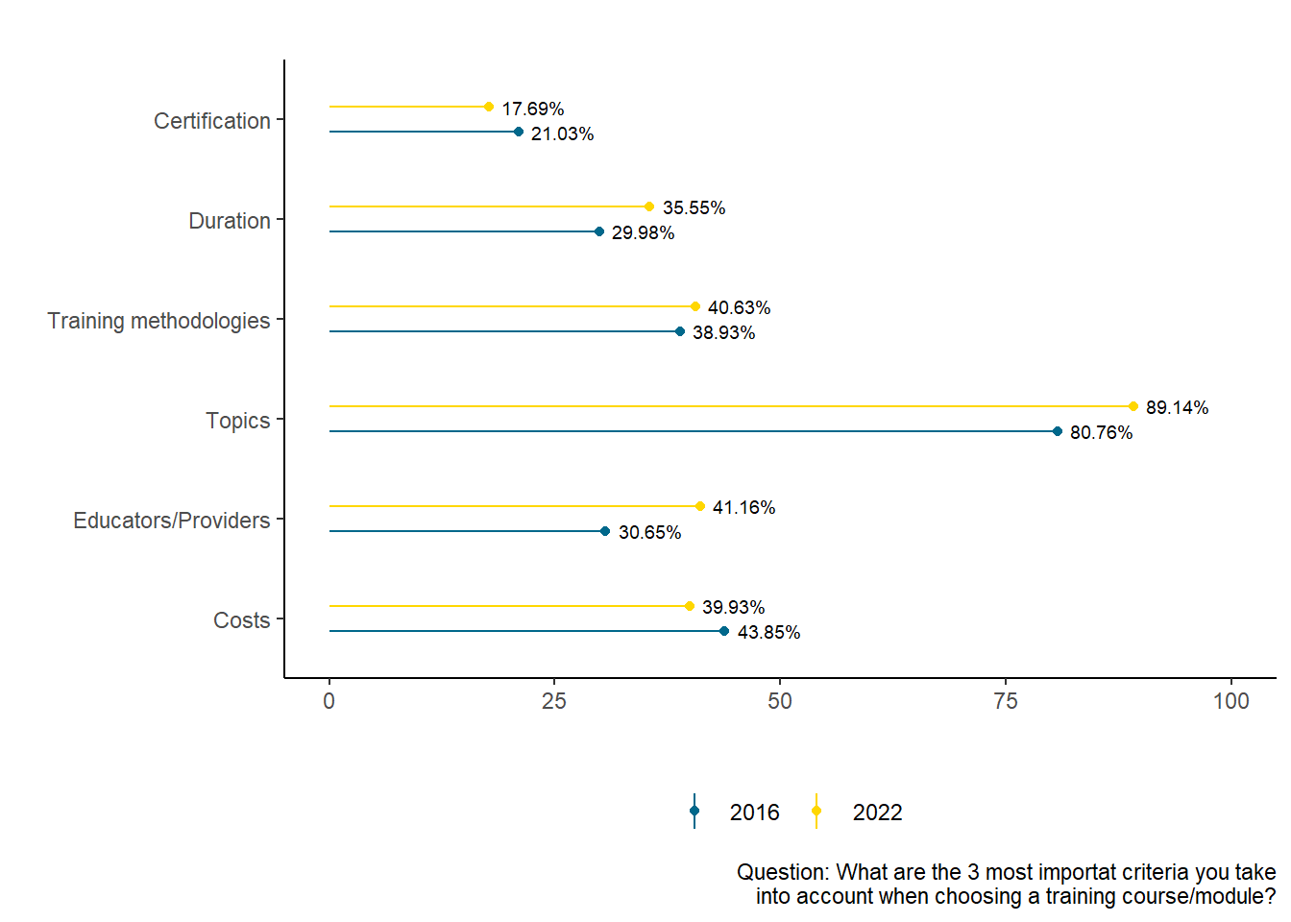
Figure 7
Prin Q12: What are the 3 main difficulties you encountered while taking part in the professional training programs offered by different providers? Li se cerea respondenților să aleagă primele 3, cele mai mari dificultăți întâmpinate participând la programele de formare oferite de diferiți furnizori (figure 8).

Q12 - What are the 3 main difficulties you encountered while taking part in the professional training programs offered by different providers? (Figure 8)
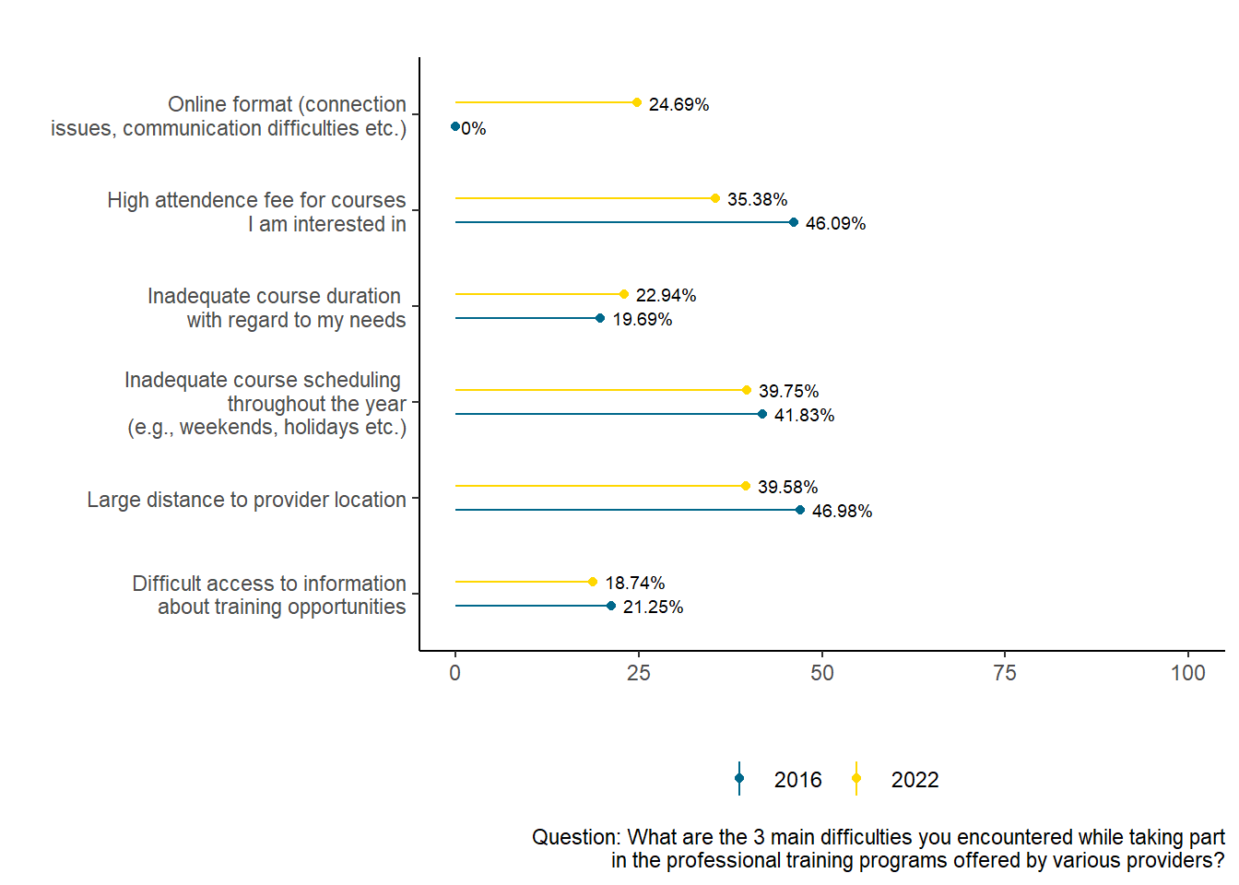
Figure 8

Q13: Speaking about course format preferences, the following results have been obtained (Figure 9):
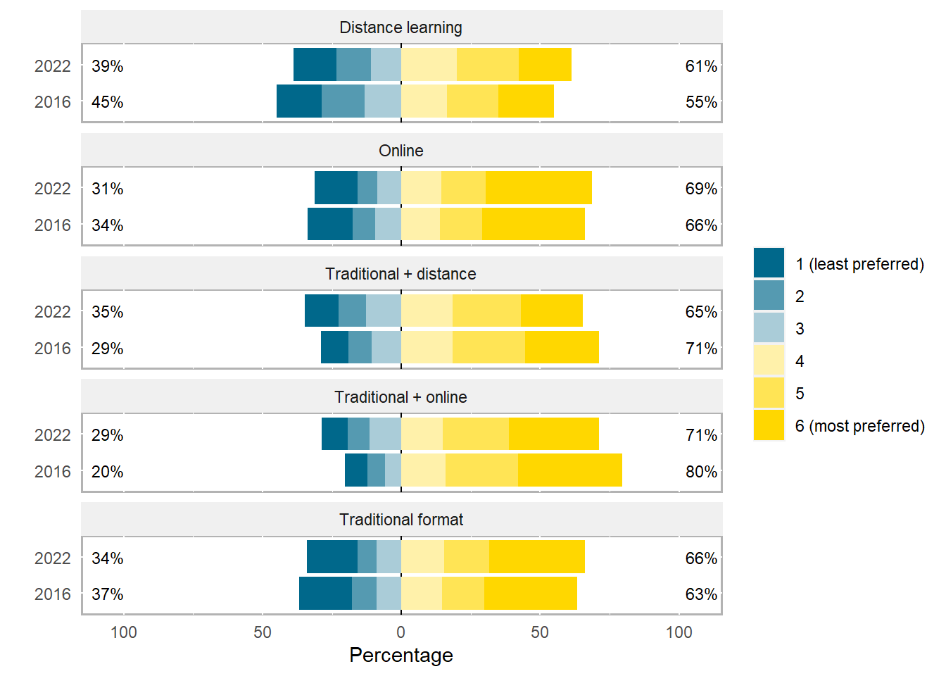
Figure 9

Answer options were traditional organization (fully physically present), remote (assuming individual work and some meetings with the trainers), online (no face to face meetings between participants and trainers), a combination of traditional and remote course, or of the remote and online ones.
Surprisingly, the working program and, implicitly, the training one, during the pandemic, did not influence significantly the preference for a certain type of organization of the trainings. The favorite kind remains the combination of traditional and online course (80% in 2016, 71% in 2022), the last choice being the remote course in both cases. In between lie the online course (with 69% in 2022 in second place and 66% in 2016 on third), the traditional one (65% in 2022 as 3rd and 63% in 2016 as 4th) and the combination of traditional and remote (65% in 2022 on 4th place and 71% in 2016 in 2nd place). Thus, participants consider the most appropriate organization is combining face to face meetings with online sessions.

Q14: Speaking about colleagues’ training needs (figure 10), respondents consider the professional training of their colleagues should focus on:
1.Updating specialization competences
2.Development of digital competences
3.Adjusting techniques of providing info-documentary services to the current needs of the users
These training avenues are always considered important (87-88% in 2022), a necessity of increasing digital competencies having been highlighted in 2022, compared to 2016 (from 84% to 88%).
The necessity to develop communication abilities with the users and colleagues follows closely, with minimal differences between the two surveys.
In conclusion, one can say the respondents consider all suggested topics as appropriate for the training of their colleagues.

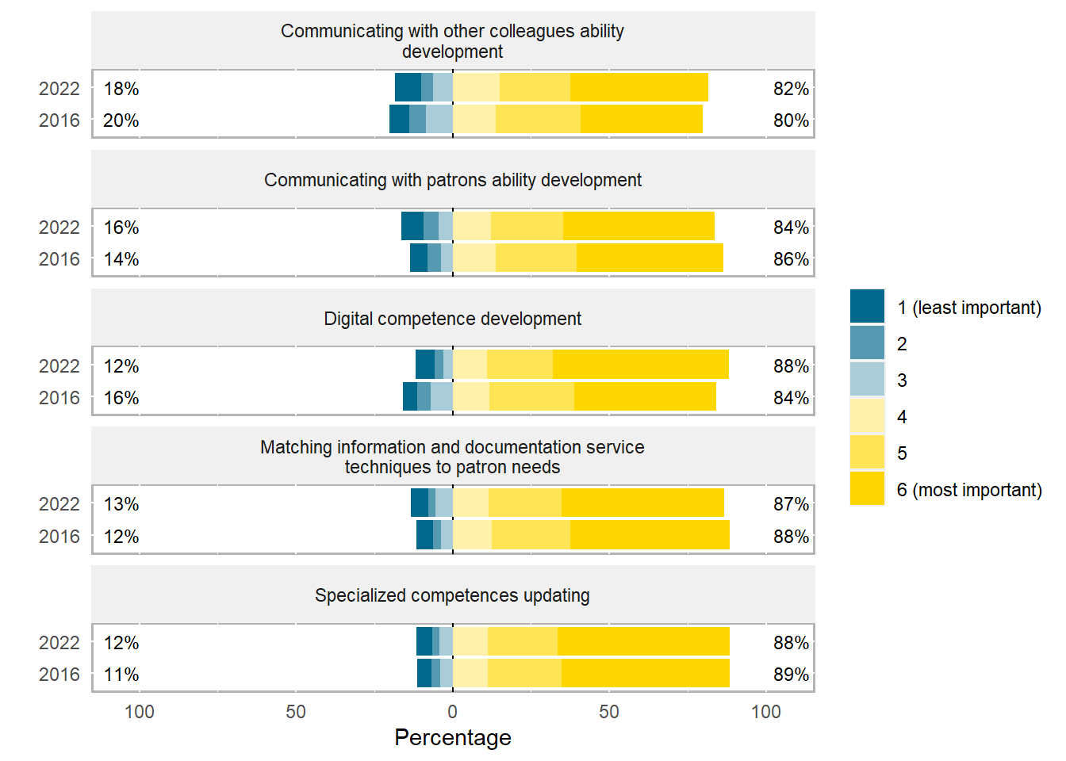
Figure 10

A comparison between their own training priorities and the needs perceived as necessary for the training of the colleagues indicate the same options as the first two choices: LIS competences and ILS competences/digital competences.

The 2 new questions refer to Q₂15 (do you consider that the pandemic has affected your professional development - to what extent) and Q₂16 (during 2022-2022, my professional training provider was.....). The results are illustrated in Table 3.
For almost 48%, the professional association was the most important training provider, on the second place is the institution they work in (>30%), followed by other providers (other info-documentary institutions). Probably one of the most reasons the professional association is a leader of training providers are the free of charges courses.
More than a third of the respondents say the restrictions during the pandemic affected to a large or very large extent their professional development. A quarter perceived it as medium influence, more than a quarter declare a small or inexistent influence, while 1/10 consider the pandmic as a favorable time for professional development. The reason for which 59 respondents say it was a period of professional growth is most likely the possibility to attend these courses online, without considering the disadvantages of this way of teaching.

Table 3
(Q₂15) Training pandemic-related disruptions | Favorable period  None  Low  Mild  High  Very high  Other |  | 59 (10.4%)  48 (8.5%)  104 (18.4%)  143 (25.3%)  126 (22.3%)  85 (15.0%)  0 (0.0%) | 
(Q₂16) Training provider  (2020 – 2022) | Professional association (as a member)  The institution I work in  Other info-documentary  structure |  | 257 (47.9%)  165 (30.8%)  114 (21.3%) | 

4. Discussions and conclusions

The topics of the courses influence significantly the attendance (Q11) and therefore they will be chosen taking this criterion into account. We estimate there are important differences in choosing the topic, based on the type of library the respondents work at. It is to be expected that specialized personnel in school libraries to opt for topics such as library collection inventory, documents borrowing, documents processing, integrated library systems, while that from university libraries to prefer bibliographic references management tools, research outputs management, access models to electronic scientific literature. There is an overlap, however, like information literacy or library project management.
Regardless of the topic, the digital competences are a priority.
This study will be followed by a more detailed analysis, with special attention being paid to obtaining results such as: the variation of subject depending on the year (wave), the variation of preferences on the subject according to respondents’ age, the variation of preferences on the subject according to level of education and the variation of preferences on the subject according to type of library the respondent works in.
The analysis of the influence of the pandemic on professional development indicate that more than 37% of the respondents have been highly or very highly affected, more than 25% chose the mild option, 27% have been affected to a small extent or not at all, and about 10% considered it a favorable period. Judging by these answers, we consider appropriate an increase in number of programs offered, as well as the diversification of their topics.

Regardless of the results of the future study, it is recommended:
-To organize courses in the preferred form by the respondents – a combination of traditional (face to face) and online; this way can partially reduce the issues cited as difficulties in choosing a course (large distance to provider location);
-To include as many practical aspects as possible (Q8), which can provide new practical ways to exercise one’s profession (Q5);
-To involve trainers from the professional association (Q8), which can partially mitigate another issue which arises when choosing a course (high attendance fee for courses); for the topics newly introduced due to the development of the field, the training of some of the best specialists in the country to become trainers themselves is necessary.
-To mainly discuss topics from the field of LIS, in a digital context, but also topics which support the application of specialty knowledge (i.e. communication skills).

When asked what they expect from a training program (Q5/Q11), respondents value the least the options obtaining certificates/diplomas (4% vs 33%), though the percentages significantly increased in 2022. Additionally, when asked what are the 3 most importat criteria you take into accout when choosing a training course/module?, the certification for obtaining a higher score in various evaluations is the least important factor. Correlating these answers with the experience so far in ALR, and considering the evaluation environment which very much values this kind of documents, it appears the motivation to obtain them is greater than that indicated by the surveys.

Specialists in a library must learn to use statistical data and performance indicators to support the library in front of the stakeholders, to prove the utility of the offered services and resources, and to conceive advocacy campaigns in order to allocate resources.

Considering the assumed role of ALR as main provider of professional development for its members and the influence of the financial factor in the decision to attend the courses, it is necessary that the Association offers authorized training courses as well. These could be organized in collaboration with large university libraries with methodologic purpose, which are also trainining providers.

5. References

BABBIE, Earl. The practice of social research. 11th ed., Belmont: Thomson Wadsworth, 2007.

BECK, Susan E.; MANUEL, Kate. Practical research methods for librarians and information professionals. New York: Neal-Schuman Publishers, 2008.

BRYER, J, SPEERSCHNEIDER, K. Likert: Analysis and Visualization Likert Items. R package version 1.3.5, 2016 [Accesat la 1.12.2022]. Disponibil la:
https://CRAN.R-project.org/package=likert.

COMTOIS, D. Summarytools: Tools to Quickly and Neatly Summarize Data. R package version 1.0.1., 2022 [Accesat la 30.1212022]. Disponibil la:
https://CRAN.R-project.org/package=summarytools.

McBURNEY, Donald H.; WHITE, Theresa L. Research methods, 7th ed., Belmont: Thomson Wadsworth, 2007.

WICKHAM, H.; AVERICK, M.; BRYAN, J.; CHANG, W.; McGOWAN, LD.; FRANCOIS, R.; GROLEMUND, G.; HAYES, A.; HENRY, L; HESTER, J; KUHN, M; PEDERSEN, T.L.; MILLER, E.; BACHE, S.M.; MULLER, K; OOMS, J.; ROBINSON, D.; SEIDEL, D.P.; SPINU, V.; TAKAHASHI, K., VAUGHAN, D.; WILKE, C.; WOO K.; YUTANI, H. Welcome to the tidyverse. In: Journal of Open Source Software, 2019, 4(43), 1686. doi:10.21105/joss.01686.

Annex 1
2016 (Q₁), 2022 (Q₂)
Q₁1  Q₂1 | What are your reasons for attending professional training programs? (6 options)
Q₁2  Q₂2 | For you, professional training is…(as importance, 6 options)
Q₁3  Q₂3 | In how many training programs have you benefited from in the last 5 years? (5 options)  In how many training programs have you benefited from in 2020-2022? (5 options)
Q₁4  Q₂4 | Do you constantly allocate time and financial resources to professional training (courses, specialty literature etc)? (6 options)
Q₁5  Q₂5 | What do you expect most from a training program? (4 options)
Q₁6  Q₂6 | Do you think your professional training corresponds to the requirements of your current and prospective job? (5 options)
Q₁7  Q₂7 | Attending training programs offer you... (3 options)
Q₁8  Q₂8 | What training method do you think appropriate? (4 options)
Q₁9  Q₂9 | What aspect of your training do you want to improve? (5 options)
Q₁10  Q₂10 | On a scale of 1 to 5, select from the suggested topics courses which you consider useful for your professional training. (13 options)  (18 options)
Q₁11  Q₂11 | What are your most important criteria in choosing a module/training course? (6 options)
Q₁12  Q₂12 | What difficulties have you encountered while attending training programs offered by various providers? (5 options)
Q₁13  Q₂13 | Regarding the organization of the training, what type of program would you prefer to follow? (5 options)
Q₁14  Q₂14 | What do you think your collegues need most? (6 options)
Q₂15 | To what degree do you consider the pandemic affected your professional training? (6 options)
Q₂16 | My provider of professional training was, in 2020-2022 (3 options)
Q₁15  Q₂17 | Age
Q₁16  Q₂18 | Gender (M, F, prefer not to say)
Q₁17  Q₂19 | Residency (rural, uban)
Q₁18  Q₂20 | Place of work (rural, urban)
Q₁19  Q₂21 | Length of employment
Q₁20  Q₂22 | Length of employment in the field
Q₁21  Q₂23 | Type of library you work in (5 options)
Q₁22  Q₂24 | Position (execution, managerial)
Q₁23 | Initial education
Q₁24  Q₂25 | Level of last completed studies/education (5 options)

